MS Decom_ZFNAMASS tcode _Changes document

Testing document for MS Decom activities.

Transaction ZFNAMASS /

Program - ZPMDBT_FNA_MASS_CREATE

System: xEM

CD: 152048

Transport request: DEMK931402

---------------------------------------------------------------------------------------------------------------------

Testing with 100+ items in the DEM system.

Below are the 3 different variants created for the 3 scenarios - standard, derived and specified.

Note: Please use the same templates which are existing in the variant to update and test the program.

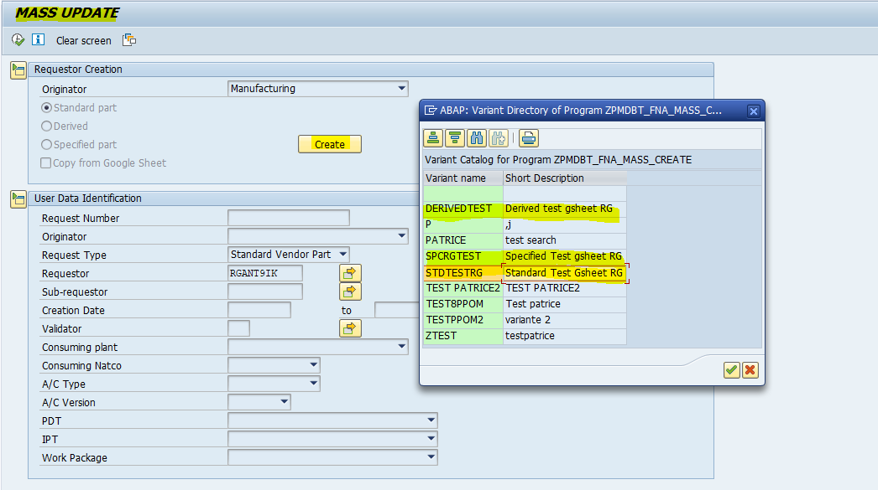

<https://docs.google.com/spreadsheets/d/1O-70wuqU_fDV_kf8P0ln9hrlzgppdbLpQZjIw6soWwM/edit?gid=403444228#gid=403444228>

1. Standard scenario:

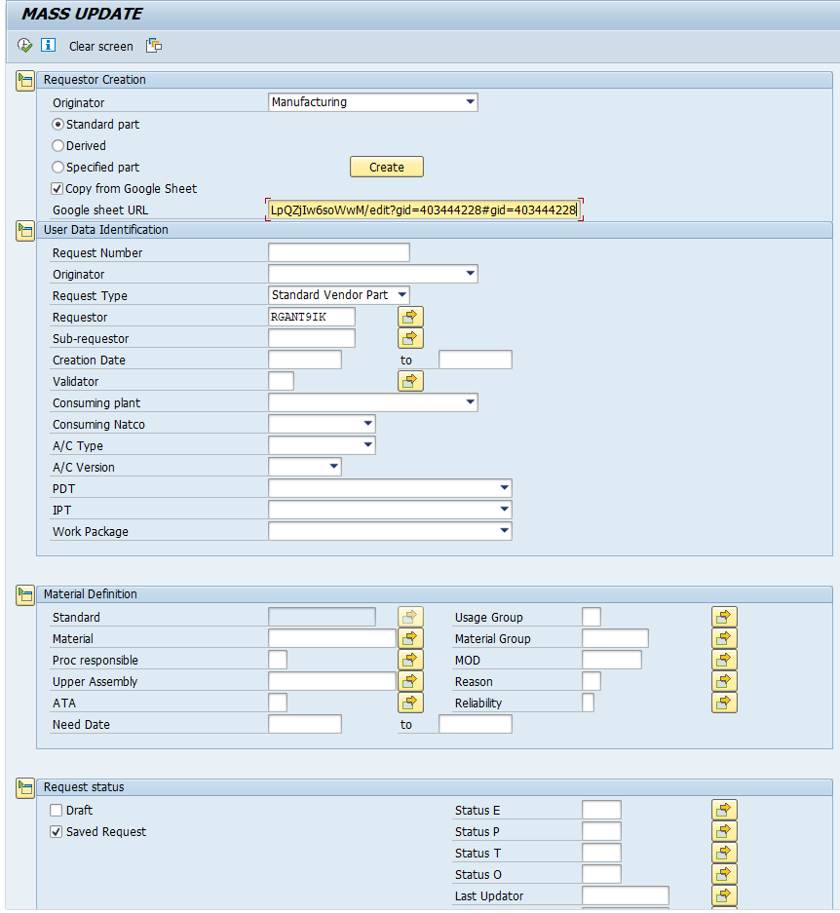

<https://docs.google.com/spreadsheets/d/1O-70wuqU_fDV_kf8P0ln9hrlzgppdbLpQZjIw6soWwM/edit?gid=403444228#gid=403444228>

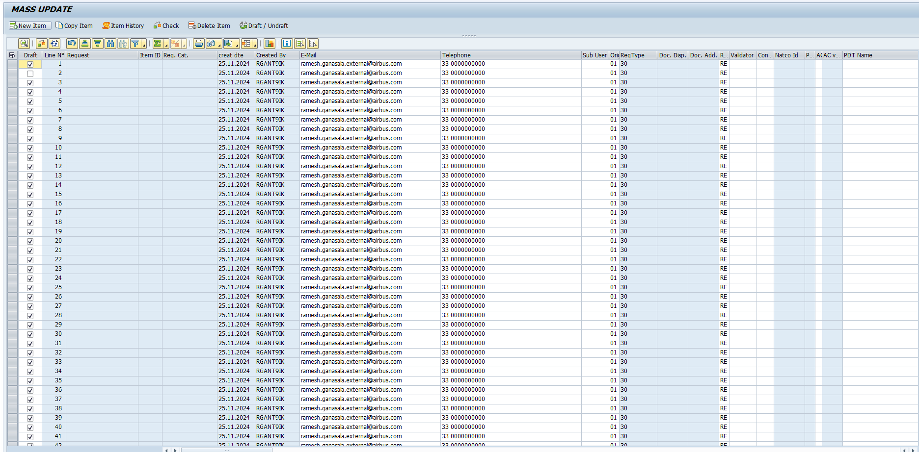

1. Specified scenario:

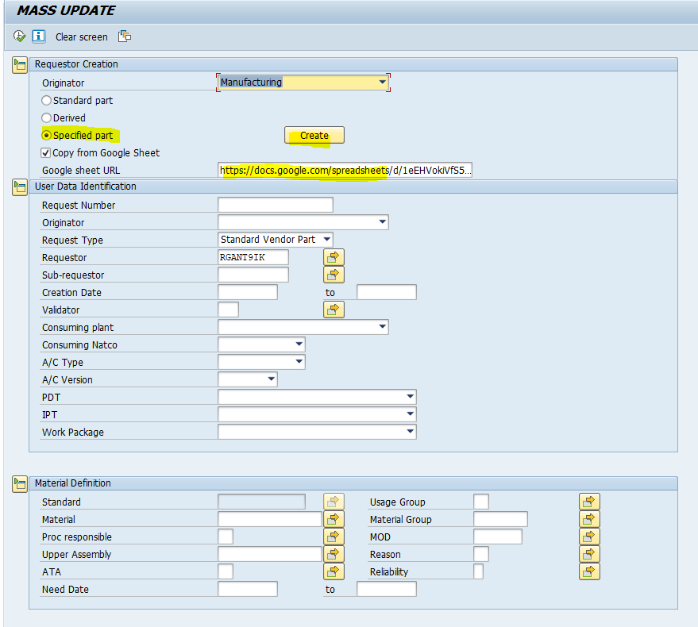

<https://docs.google.com/spreadsheets/d/1eEHVokiVfS5MFXlb6Sh3wbjACAHoM8Qu1S2TdZ-uAbE/edit?gid=165907936#gid=165907936>

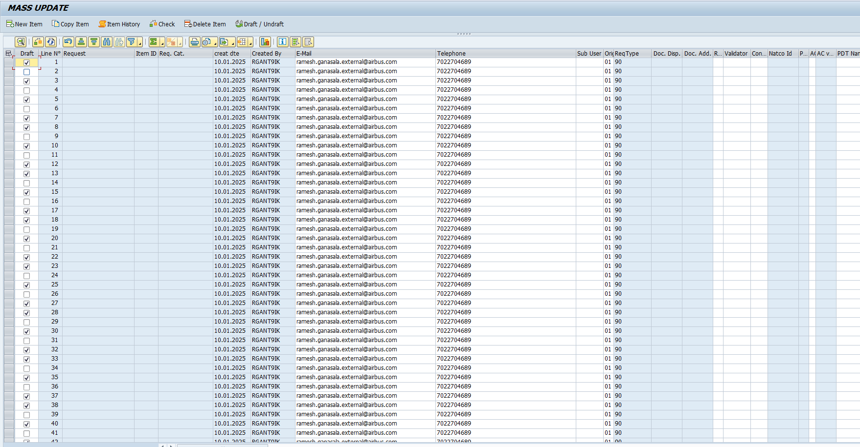

1. Derived scenario:

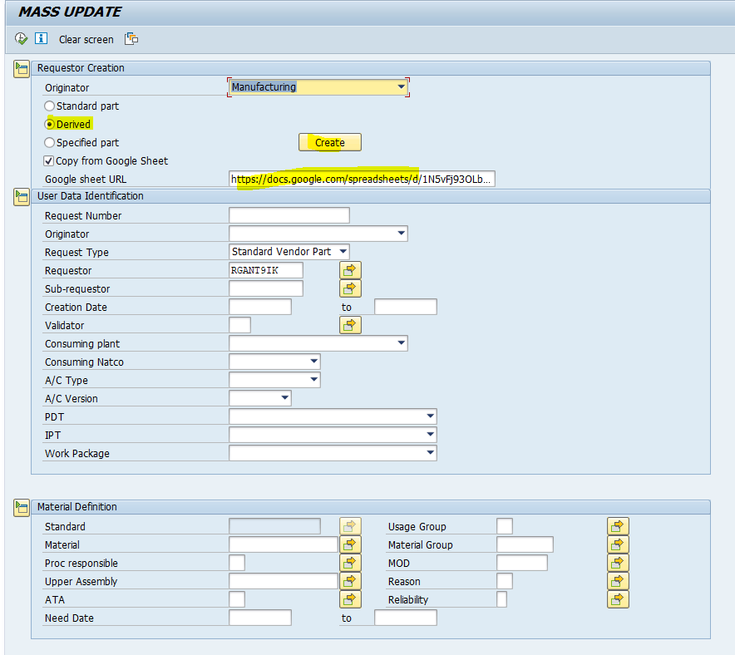

<https://docs.google.com/spreadsheets/d/1N5vFj93OLbTZykhL03656qpZ1CYiGV8HOkcz1J03LAY/edit?gid=1310215276#gid=1310215276>

